**Exercise 10: Employee Management System – Hibernate-Specific Features**

Business Scenario:

Leverage Hibernate-specific features to enhance your application's performance and capabilities.

**1. Hibernate Specific Annotations:**

Hibernate offers several annotations that provide additional customization for entity mappings beyond standard JPA annotations. I used hibernate annotations like:

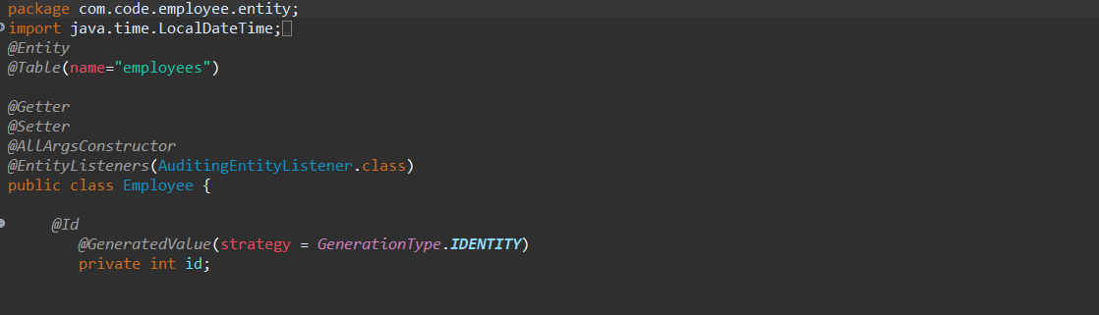

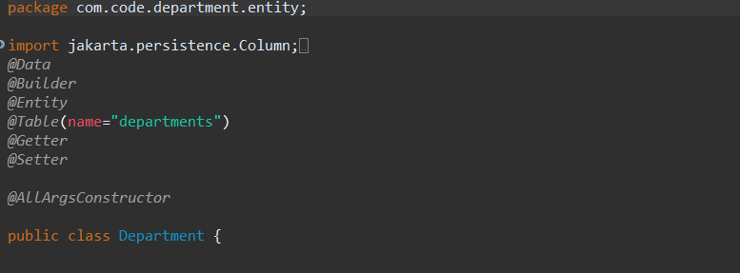

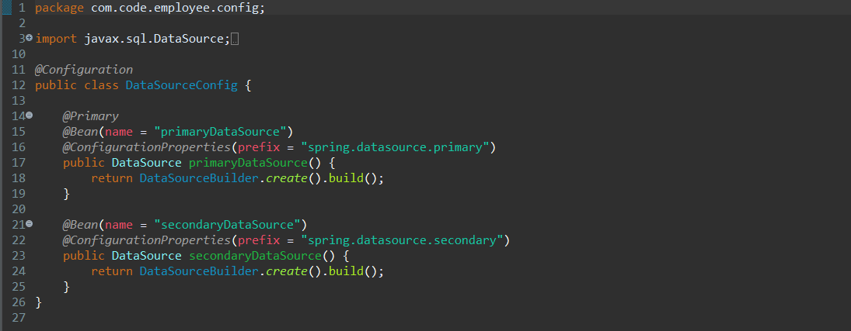

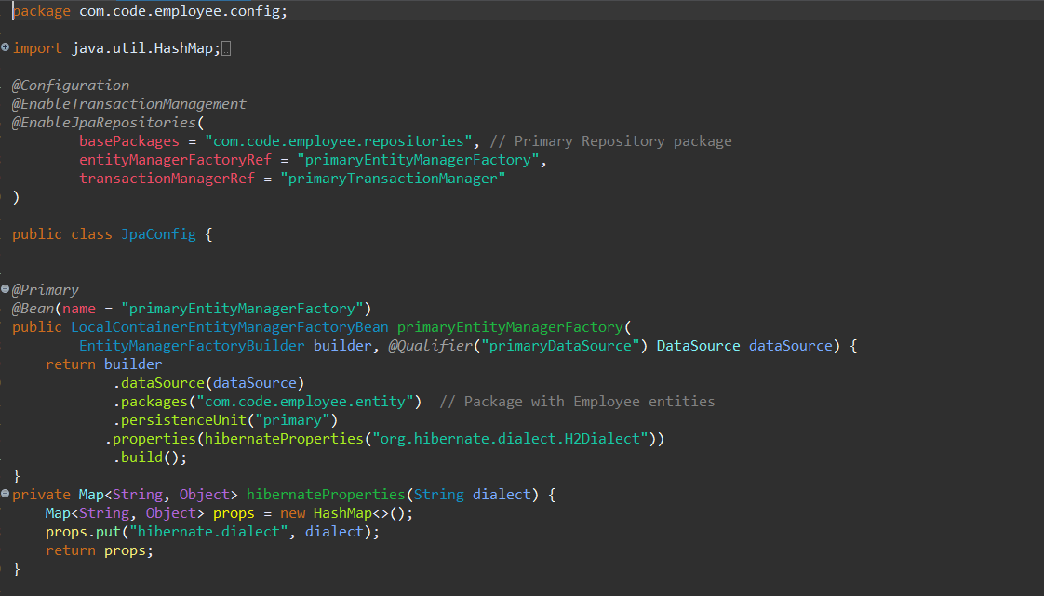

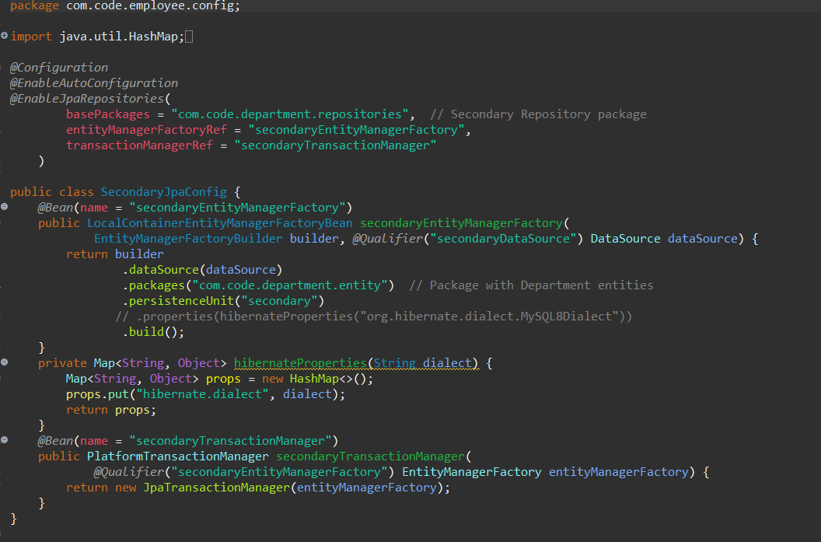

**2. Configuring Hibernate Dialect and Properties**

**3. Batch Processing:**

* Proper configuration of Hibernate dialect and properties can significantly improve performance and ensure compatibility with the database.
* Batch processing in Hibernate allows us to efficiently perform bulk operations by grouping multiple statements into a single batch.

**application.Properties**

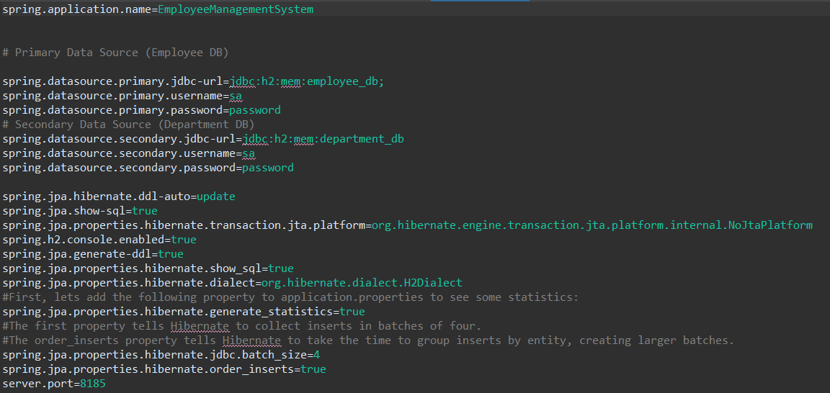

I declared a Post Mapping named “/bulkadd” for implementing Batch processing in DepartmentController.java

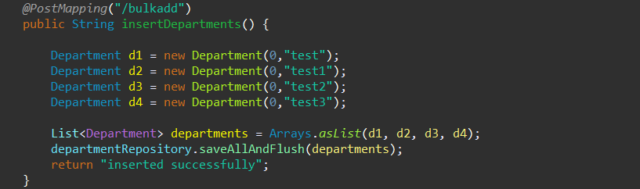

**Output:**

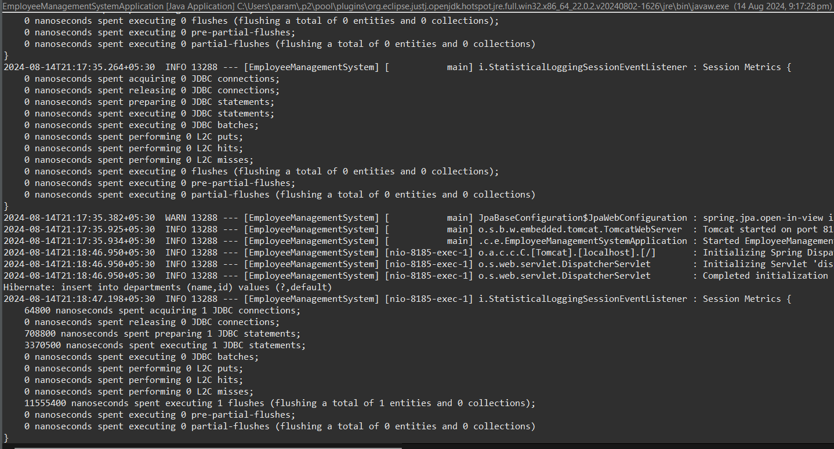

**Class Diagram:**

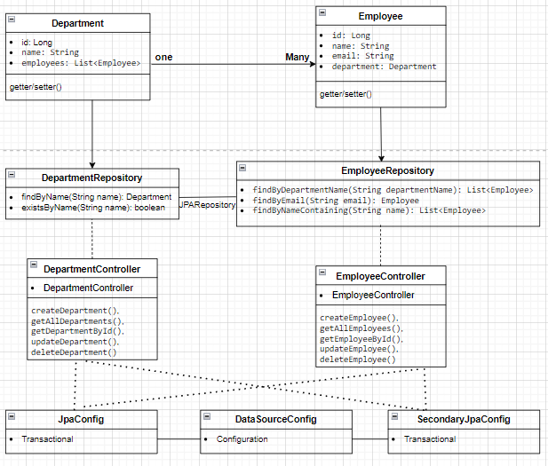

**• Department Class:**

* **Attributes: Represents the id, name, and a list of Employee objects.**
* **Relationship: Has a one-to-many relationship with Employee.**

**• Employee Class:**

* **Attributes: Represents the id, name, email, and a reference to the Department object.**
* **Relationship: Each Employee belongs to a single Department.**

**• EmployeeRepository Interface:**

* **Methods:**
  + **findByDepartmentName(String departmentName): List<Employee>**
  + **findByEmail(String email): Employee**
  + **findByNameContaining(String name): List<Employee>**

**• DepartmentRepository Interface:**

* **Methods:**
  + **findByName(String name): Department**
  + **existsByName(String name): Boolean**

**• EmployeeController Class:**

* **Methods:**
* **createEmployee()**
* **getAllEmployees()**
* **getEmployeeById()**
* **updateEmployee()**
* **deleteEmployee().**

**• DepartmentController Class:**

* **Methods**
* **createDepartment()**
* **getAllDepartments()**
* **getDepartmentById()**
* **updateDepartment()**
* **deleteDepartment()**

**• DataSourceConfig Class:**

**• JpaConfig Class:**

**• SecondaryJpaConfig Class:**

**Analysis:**

**• Hibernate-Specific Annotations:**

* Use @Type, @Formula, @DynamicUpdate, and @Immutable to customize entity mappings and behaviour.

**• Configuring Hibernate Dialect and Properties:**

* Set the Hibernate dialect for the database.
* Adjust properties like batch_size, order_inserts, and order_updates to optimize performance.

**• Batch Processing:**

* Enable batch processing to handle bulk operations efficiently.
* Use the Session API to implement batch processing in the application code.

**Relationship:**

* A Department can have many Employees (OneToMany relationship).
* An Employee belongs to one Department (ManyToOne relationship).
* Department to DepartmentRepository
* Employee to EmployeeRepository
* DataSourceConfig to JpaConfig and SecondaryJpaConfiig